## Task 01: Create Materialized Views - ON DEMAND

CREATE MATERIALIZED VIEW mv_monthly_rep_demand

BUILD IMMEDIATE

AS

SELECT tariff_type

, tariff_name

, tariff_code

, operation_method_type

, am_sum

, count_tr

, ROUND ( 100 * am_sum / ( SUM ( am_sum ) OVER (PARTITION BY tariff_type) )

, 3 ) prg

, profit

FROM ( SELECT tariff_type

, tariff_name

, tariff_code

, operation_method_type

, ROUND ( SUM ( payment_sum / currency_to_dollar )

, 2 )

am_sum

, COUNT ( payment_sum / currency_to_dollar ) count_tr

, ROUND ( SUM ( ( payment_sum / currency_to_dollar ) * tariff_payment_sum / 100 )

, 2 )

profit

FROM u_sa_data.tmp_transactions_info

WHERE tariff_type IN ('Local Transfer', 'International Transfer')

AND event_dt >= TRUNC ( TO_DATE ( '01-APR-2007'

, 'dd-mon-yyyy' )

, 'month' )

AND event_dt <= (TRUNC ( TO_DATE ( ADD_MONTHS ( TO_DATE ( '01-APR-2007'

, 'dd-mon-yyyy' )

, 1 ) )

, 'month' )

- 1)

GROUP BY tariff_type, tariff_name, tariff_code, operation_method_type );

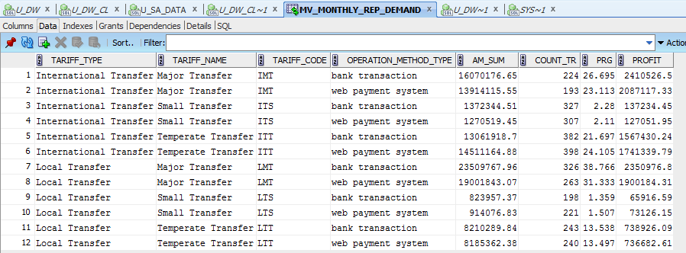

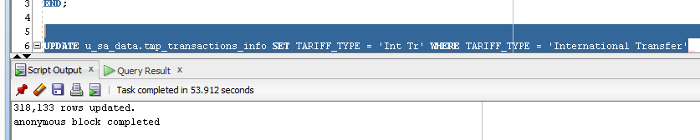

BEGIN

***dbms_mview.refresh*** ( 'MV_MONTHLY_REP_DEMAND'

, 'c' );

END;

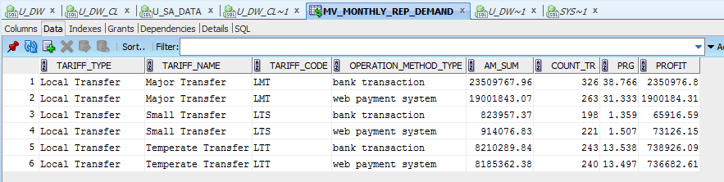

## Task 02: Create Materialized Views - ON COMMIT

CREATE MATERIALIZED VIEW LOG ON u_sa_data.tmp_transactions_info

WITH PRIMARY KEY

INCLUDING NEW VALUES;

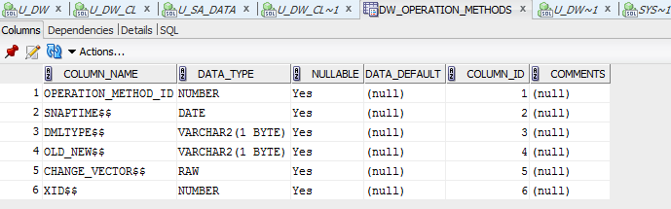

CREATE MATERIALIZED VIEW mv_daily_rep_commit

BUILD IMMEDIATE

REFRESH ON COMMIT

AS SELECT

tariff_type

, tariff_name

, tariff_code

, operation_method_type

, SUM ( payment_sum / currency_to_dollar )

am_sum

, COUNT ( payment_sum / currency_to_dollar ) count_tr

, SUM ( ( payment_sum / currency_to_dollar ) * tariff_payment_sum / 100 )

profit

, COUNT ( ( payment_sum / currency_to_dollar ) * tariff_payment_sum / 100 ) cnt1

FROM u_sa_data.tmp_transactions_info

WHERE tariff_type IN ('Local Transfer', 'International Transfer')

AND TRUNC ( event_dt

, 'DAY' ) = TO_DATE ( '15-APR-07' )

GROUP BY tariff_type,tariff_code, tariff_name, operation_method_type;

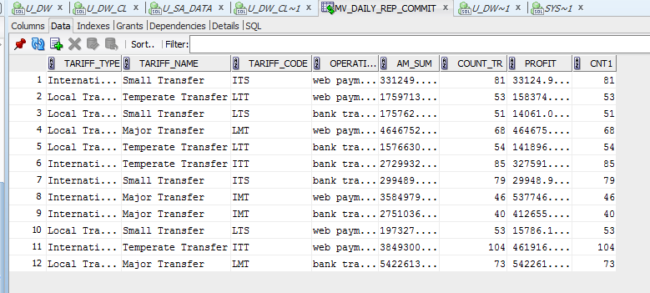

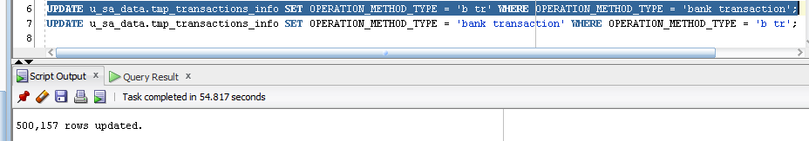

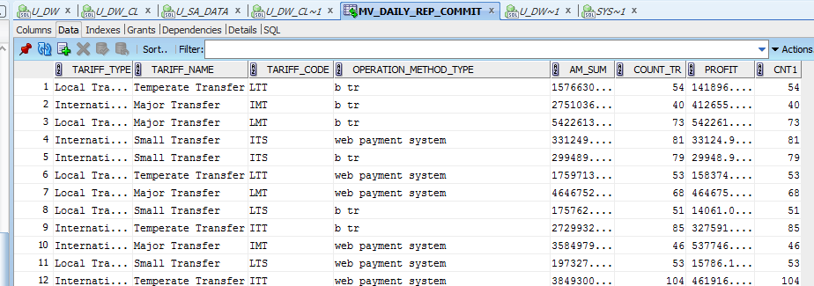

## 

## Task 03: Create Materialized Views - Refreshing at definitive Time moment

CREATE MATERIALIZED VIEW monthly_rep_model

REFRESH START WITH SYSDATE NEXT SYSDATE + 1/1440

AS

SELECT event_dt

, tariff_type

, tariff_name

, am_sum

, count_tr

, profit

, prg

FROM ( SELECT TRUNC ( TO_DATE ( event_dt

, 'dd-mon-yy' )

, 'month' )

event_dt

, tariff_type

, tariff_name

, tariff_payment_sum

, SUM ( SUM ( payment_sum / currency_to_dollar ) ) OVER (PARTITION BY tariff_type) par_sum

, SUM ( payment_sum / currency_to_dollar )

am_sum

, COUNT ( payment_sum / currency_to_dollar ) count_tr

FROM u_sa_data.tmp_transactions_info

WHERE tariff_type IN ('Local Transfer', 'International Transfer')

AND tariff_name IN ('Small Transfer', 'Temperate Transfer')

AND TO_CHAR ( TRUNC ( event_dt

, 'YYYY' )

, 'YYYY' ) IN ('2012')

GROUP BY (tariff_type, tariff_name, TRUNC ( TO_DATE ( event_dt

, 'dd-mon-yy' )

, 'month' ), tariff_payment_sum))

MODEL RETURN UPDATED ROWS

PARTITION BY ( tariff_type, tariff_name )

DIMENSION BY ( event_dt )

MEASURES ( 0 prg, 0 profit, am_sum, par_sum, count_tr, tariff_payment_sum )

RULES AUTOMATIC ORDER

( prg [event_dt] = ROUND ( ( 100 * am_sum[CV ( event_dt )] / par_sum[CV ( event_dt )] )

, 5 ),

profit [event_dt] = ROUND ( ( count_tr[CV ( event_dt )] * tariff_payment_sum[CV ( event_dt )] / 100 )

, 2 ) );

